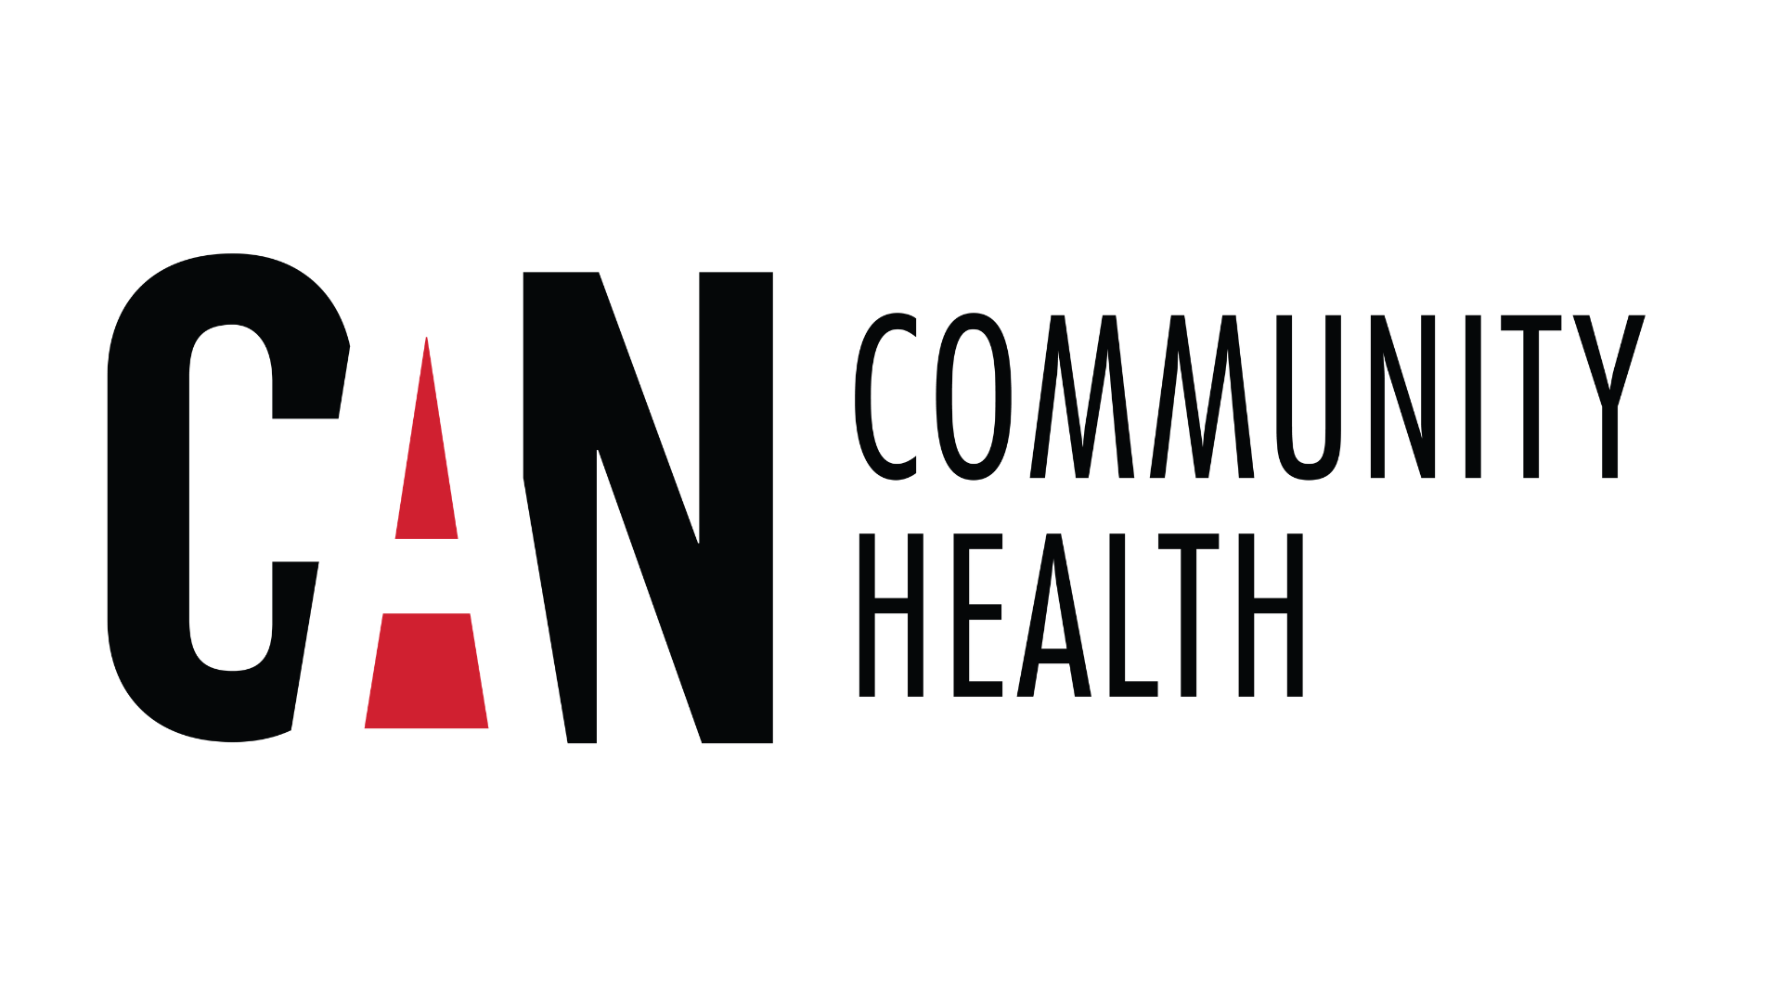 | FOR IMMEDIATE RELEASE  Media Contact  Daniel Furbee  dfurbee@cancommunityhealth.org  (740)589-0041
CAN Community Health Awarded Community Foundation of Sarasota County Grant to Expand Access to Dental Care

SARASOTA, Fla. – CAN Community Health has been awarded a $10,000 grant from the Community Foundation of Sarasota County to strengthen its dental practice, expanding access to essential oral healthcare for individuals living with or affected by HIV.
The funding, made possible by the R. Covell Radcliffe Fund and the Zella I. and Junius F. Allen Fund, will help CAN Community Health meet the growing demand for specialized dental services while supporting clinical operations and improving access to care for patients throughout the region.

“Oral health is an essential part of overall health, especially for people living with HIV,” said Dawn Brown, Director of Dental Operations at CAN Community Health. “We are incredibly grateful to the Community Foundation of Sarasota County for investing in the health of our community.”

Since opening in 2016, the Sarasota dental practice has become a vital resource for individuals who often face significant barriers to oral healthcare. Today, the clinic serves more than 800 active patients, with the majority residing in Sarasota and Manatee counties. Approximately 15% of patients travel from neighboring counties, including Pinellas, Hillsborough, Lee, and Charlotte, demonstrating the clinic’s regional impact and the growing need for specialized dental care.

“This grant will help us reach more patients, reduce barriers to care, and ensure individuals receive the dental services they need to live healthier lives,” said Brown.

Operating with a dedicated team of one dentist, one dental hygienist, and two dental assistants, the clinic provides comprehensive preventive and restorative dental services to an underserved population. As demand continues to increase, the grant will help CAN Community Health strengthen clinic operations, improve access to appointments, and continue delivering high-quality care to those who need it most.

For people living with HIV, maintaining good oral health is closely linked to overall health and wellness. Access to regular dental care can help prevent infections, improve confidence, and enhance quality of life.

“We’re honored to receive this support from the Community Foundation of Sarasota County,” said Brown. “Their investment reflects a shared commitment to improving health outcomes in our Sarasota community and ensures more individuals have access to quality dental care regardless of their financial circumstances.”

####
About CAN Community Health
CAN Community Health is the nation's premier resource in ending epidemics. Headquartered in Tampa, Florida, CAN Community Health operates clinics and pharmacies across Arizona, Florida, Nevada, South Carolina, Texas, and Virginia. CAN Community Health delivers high-quality care to those affected by HIV/AIDS, Hepatitis C, STI's, and more. For more than 30 years, CAN Community Health has been empowering wellness for all through outreach, integrated clinical practice, advocacy, education, and research. For more information about CAN Community Health and its services, please visit www.CANCommunityHealth.org.
About the Community Foundation of Sarasota County
The Community Foundation of Sarasota County is a public charity founded in 1979 by the Southwest Florida Estate Planning Council as a resource for caring individuals and the causes they support, enabling them to make a charitable impact on the community. With assets of $605 million in more than 1,600 charitable funds, the Community Foundation awarded grants and scholarships totaling $44.7 million last year in the areas of education, the arts, health and human services, civic engagement, animal welfare and the environment. Since its founding, the Community Foundation has been able to grant $542 million to nonprofits in our community thanks to the generosity of charitable individuals, families and businesses. For more information, visit cfsarasota.org or call 941-955-3000.

